국문 제목(신명조, 14, 줄간격1줄)

이름^{1,+}·이름²(신명조, 10, 줄간격1줄)
¹서울대학교 전기컴퓨터공학부(School of Electrical Engineering, Seoul National Unversity)
SoEECS 301-1014, Seoul National University, 599 Gwanangno, Gwanak-gu, Seoul 151-744, Korea
²서울대학교 전기컴퓨터공학부(School of Electrical Engineering, Seoul National Unversity)
SoEECS 301-1014, Seoul National University, 599 Gwanangno, Gwanak-gu, Seoul 151-744, Korea
⁺Corresponding author: name@snu.ac.kr
(Received : Mar. 2, 2012, Revised : Jun. 22, Jul. 9, 2012, Accepted : Aug. 2, 2012)

This is an Open Access article distributed under the terms of the Creative Commons Attribution Non-Commercial License(http://creativecommons.org/licenses/bync/3.0)which permits unrestricted non-commercial use, distribution, and reproduction in any medium, provided the original work is properly cited.

Paper Title(Times New Roman, 14, Line Height 1)

Name¹⁺ and Name²(Times New Roman, 11, Line Height 1)

Abstract(Times New Roman, 11, Line Height 1)

Please put the abstract of here.(Times New Roman, 10, Line Height 1)
The number of abstract should be in the range of 150 words ~ 200 words.

Keywords : Gas sensors, Oxide semiconductors, SnO₂, Propane gas (Times New Roman, 10, Line Height 1)

서론(신명조, 11, 줄간격 1줄)

여기에 서론을 입력하세요.(신명조, 9, 줄간격 1줄)

연구 방법(신명조, 11, 줄간격 1줄)

2.1 각 절 제목(신명조, 9, 줄간격 1줄)

여기에 내용을 입력하세요. (신명조, 9, 줄간격 1줄)

2.1.1 각 항 제목(신명조, 9, 줄간격 1줄)
여기에 내용을 입력하세요. (신명조, 9, 줄간격 1줄)

2.1.1.1 각 항 제목(신명조, 9, 줄간격 1줄)
여기에 내용을 입력하세요. (신명조, 9, 줄간격 1줄)

결과 및 고찰(신명조, 11, 줄간격 1줄)

3.1 각 절 제목(신명조, 9, 줄간격 1줄)

여기에 내용을 입력하세요. (신명조, 9, 줄간격 1줄)

3.1.1 각 항 제목(신명조, 9, 줄간격 1줄)
여기에 내용을 입력하세요. (신명조, 9, 줄간격 1줄)

Table 1. Please put the title of table here.(Times New Roman, 10, Line Height 1)
All the contents in table should be given in English.
item1 | item2 | item3

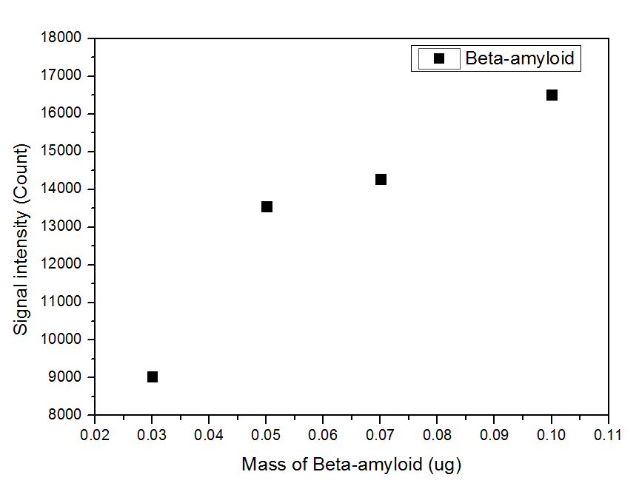
Fig. 1. Please put the title of figure here.(Times New Roman, 10, Line Height 1)

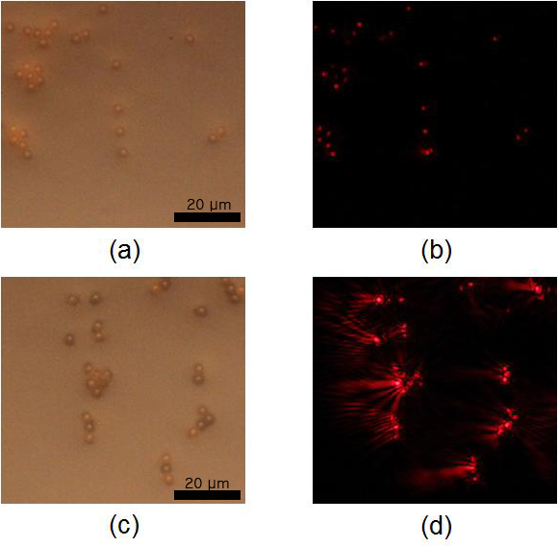
Fig. 2. Please put the title of figure here ; (a) Aaa, (b) Bbb, (c) Ccc, (d) Ddd.

수식 맨 끝에 번호를 기입하세요.

$\begin{aligned}\int{ F(r,ϕ)} \text{dr} dϕ=[{σr}_{2} (2μ_{0})] \\ ⋅ \int{ \text{exp}}(−λ|z_{j}−z_{i}| ) λ^{−1} J_{1}(λ r_{2}) J_{0}(λ r_{i}) dλ \text{.}\end{aligned}$(1)

결론(신명조, 11, 줄간격 1줄)

여기에 결론을 입력하세요. (신명조, 9, 줄간격 1줄)

감사의 글(신명조, 11, 줄간격 1줄)

여기에 감사의 글을 입력하세요. (신명조, 9, 줄간격 1줄)

REFERENCES(Time New Roman, 12, Line Height 1)

Write references here.(Time New Roman, 10, Line Height 1) All references should be given in English.

A. In the case of journals: Names of the authors, “title”, name of the journal in italic type, volume number, page numbers and year published.

[1] T. Takalokastari, S. J. Jung, D. D. Lee, and W. Y. Chung, “Real time drowsiness detection by WSN based wearable ECG measurement system”, J. Sensor Sci. & Tech., Vol. 20, No. 6, pp. 382-387, 2011.

B. In the case of books: Names of the authors, name of the book in italic type, publishing company, place published, page numbers and year published.

[1] J. Ruzicka and E. M. Hansen, Chemical Analysis, John Wiley & Sons, New York, pp. 180-182, 1988.

C. In the case of conference papers: Names of the authors, “title”, name of the proceeding in italic type, page numbers, place, country and year published.

[1] W. G. Jeon and Y. S. Cho, “An equalization technique for OFDM and MC-CDMA in a multipath fading channels”, Proc. of IEEE Conf. on Acoustics, Speech and Signal Processing, pp. 2529-2532, Munich, Germany, 1997.

D. In the case of web sites: URL, access date.

[1] http://www.sensors.or.kr/ (retrieved on Sep. 8, 2012).

성명(English Name)
•19**년 **대학교 **과(*학사)
•19**년 **대학교 **과(*석사)
•19**년 **대학교 **과(*박사)
•****년 ~ ****년 경력사항
•****년 ~ 현재 경력사항
•관심분야 : **
(신명조, 9, 줄간격 1줄)

